P | G | K | X | H | R | R | H | I | N | O | V | M | D | K
L | I | Q | I | B | E | E | H | Q | U | D | O | U | R | P
U | M | P | P | C | G | Y | D | K | R | P | L | A | H | G
C | P | N | T | E | I | Q | I | P | H | O | U | K | K | X
O | E | J | O | P | T | P | X | Z | P | Z | I | V | S | V
O | Q | C | S | S | B | G | V | A | W | E | F | V | T | T
O | Z | V | N | A | F | U | O | J | W | B | S | L | H | T
Q | C | A | P | G | S | G | I | R | N | R | Q | N | N | N
D | K | P | P | A | R | R | O | T | I | A | N | A | F | J
E | Z | C | N | O | H | V | P | M | W | L | H | H | Y | N
G | I | R | A | F | F | E | U | O | O | P | L | E | I | A
E | L | I | D | O | C | O | R | C | E | U | K | A | K | O
E | J | F | Z | P | Z | P | G | L | W | N | S | L | V | D
V | C | N | H | S | I | L | E | C | O | A | S | E | M | H
P | N | O | I | L | V | A | L | M | B | U | H | I | L | O
WILD ANIMALS WORDSEARCH
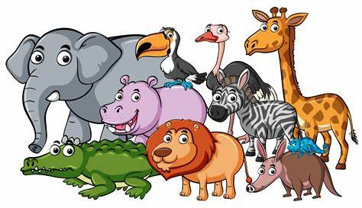
CROCODILE | ELEPHANT | GIRAFFE
GORILLA | HIPPO | LION
MONKEY | MOUSE | PARROT
RHINO | SNAKE | TIGER
ZEBRA

