T | F | L | Z | X | X | R | N E | E | E
N | S | R | E | X | Z | O | A F | F | U
A | S | P | B | M | I | W | J F | F | D
H | M | K | R | L | O | I | J A | A | N
P | C | O | A | E | T | C | P R | R | T
E | N | H | N | B | C | R | A I | I | O
L | R | D | F | K | V | D | R G | G | R
E | R | O | R | U | E | Z | R V | V | R
H | I | P | P | O | D | Y | O Y | Y | A
Z | Y | N | R | C | A | O | T P | P | P

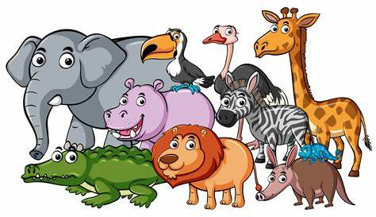
HIPPO ELEPHANT ZEBRA LION MONKEY GIRAFFE PARROT
WILD ANIMALS WORDSEARCH

